PARSEC Ruby Bootcamp
― Pre-Course Reading List ―
Seven Recommended Books
for the
Serious Ruby Student
The PARSEC Ruby Bootcamp will be a demanding, challenging deep-dive into the Ruby programming language, yet we anticipate that students will come to the Bootcamp with a variety of pre-existing skills and backgrounds. Although the Bootcamp is not appropriate for absolute beginners in software programming, neither are we expecting seasoned coding gurus ― most students will be in the early stages of their study, preparation and experience curve as coders.
With this in mind, we’d like all of our Ruby Bootcamp students to have a “leg up” on core concepts before the Bootcamp begins ― We offer the following reading list as one means for you to gain that advantage.
If you are serious about getting the most out of your Bootcamp training experience, select and read at least two books from the following list; if you are truly diligent, you just might tackle even more of them.
During the first week of Bootcamp, you will be asked to present an oral book report and recommendation to the class on at least one of the titles that you’ve read.
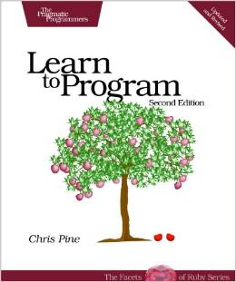
- Learn to Program ― Chris Pine (ISBN 978-1-93435-636-4, 2009, Pragmatic Bookshelf, 2nd Edition). If your exposure to programming has been, up to this point, incomplete, fragmented and/or light, then this is a great first book to read and work through. Be sure to do all of the Exercises, no matter how trivial they might look! Chris has a deft and irreverent touch with this introductory material ― enjoy his humor, even the corny jokes.

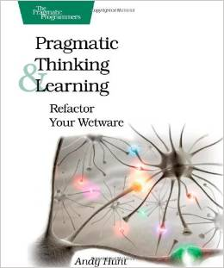
- Pragmatic Thinking & Learning ― Refactor Your Wetware ― Andy Hunt (ISBN 978-1-93435-605-0, 2009, Pragmatic Bookshelf). Ruby Bootcamp is going to hit your mind with a firehose full of information. This book will help you prepare to deal with it. Essential.

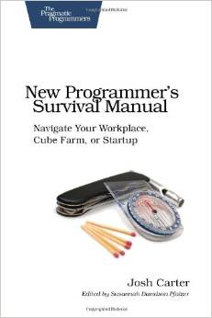
- New Programmer’s Survival Manual ― Joshua Carter (ISBN 978-1-93435-681-4, 2011, Pragmatic Bookshelf). Many Bootcamp students are likely making career pivots into the software industry... What’s it like to work on a software development team for a big (or, for that matter, a small) company? What should you expect? How do you fit into a team? How do you deal with a non-technical manager? How do you survive the office politics? This little book is a good start in understanding what you’re pivoting into…

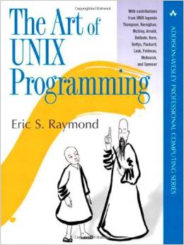
- The Art of UNIX Programming ― Eric S. Raymond (ISBN 007-6-09202-536-8, 2003, Addison-Wesley). UNIX has been around for almost as long as computing has been recognized as a career path, and will be around for a lot longer, too. Even if your first software development position doesn’t involve UNIX (or Linux), you won’t be far away from it. Eric Raymond is one of computing’s best practitioners and historians, and he illuminates the philosophy, design patterns, tools, culture and traditions that make UNIX one of the most influential operating systems on the planet. You’ll get the Big Picture here like no one else has explained it; and this is complemented by running commentary from thirteen of the pioneers in the UNIX diaspora: Ken Thompson (the Inventor of UNIX), Ken Arnold, Steve Bollovin, Stuart Feldman, Jim Gettys, Keith Packard, Steve Johnson, Brian Kernighan, David Korn, Mike Lesk, Doug McIlroy, Marshal Kirk McKusick and Henry Spencer.
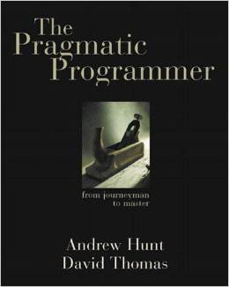
- The Pragmatic Programmer ― Andrew Hunt and David Thomas (ISBN 978-2-20151-522-4, 1999, Addison-Wesley). In a sense, this is the book that started the modern decades of computing, including the Extreme Programming, Agile and Test-Driven Development methodologies, and much more. Don’t ask to borrow someone’s copy, most programmers just won’t loan or part with this book. It expounds the core of what modern software development, and the dev-ops team, is all about.

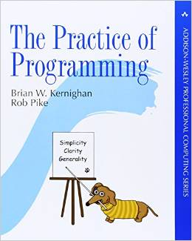
- The Practice of Programming ― Brian Kernighan and Rob Pike (ISBN 078-5-34261-586-9, 1999, Addison-Wesley). This is the standard reference on good ― no, great ― coding design, style and practice, the one that all competent coders turn to… With the clearest of intentions and prose, Kernighan and Pike show you “Do this… not that,” and why. This is a rich reference book for the beginner and the expert alike.

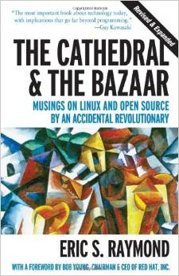
- The Cathedral and The Bazaar: Musings on Linux and Open Source by an Accidental Revolutionary ― Eric S. Raymond (ISBN 978-0-59600-108-7, 2001, O’Reilly). As suggested by its subtitle, this is a collection of essays ― trenchant observations, really ― by one of the software industry’s most intelligent and seasoned observers and practitioners. Eric Raymond ― no slouch of a coder/hacker himself ― began digging into the then-mysterious phenomenon of the “open source software” movement, and quickly found himself documenting the founding principles together with the why-this-works of it all. And, as open source continues to turn traditional software business models on their head ― it is, after all, a business model itself ― every aspiring software developer needs to understand not only the financial impetus, but the social imperative which underlies the world of software, from privacy to security to basic human rights. This is the foundational book on the subject.
Final note: We recommend that students obtain used technical books wherever possible, usually at a considerable price savings. Amazon.com typically provides a large selection of used books available from their affiliate sellers across the nation and world. Buy used books!

